International Information Technology University JSC

Faculty of Information Technology

Department of Information Systems

**«Software requirements specification development»**

**for discipline «Fundamentals of information systems»**

Zhumabekov Dias and Alimzhanov Adil

**______________________________________________________**

**(Authors)**

GPS WakeApper

**__________________________________________________________________**

**(TOPIC)**

**Almaty, 2022**

**1 INTRODUCTION**

Possibility to turn on the alarm, guided by the map inside the application. You, being in transport, must get from point A to point B. Between points A and B, for example, there are 20 stops. You want to take a nap, and with our app, you can set the alarm at the 19th stop, between points A and B.

**2 GENERAL INFORMATION**

**2.1 Full name of IS and its abbreviation**

GPS WakeApper

**2.2 Information about developers and customers**

*Company:* LLC “Yandex”

Costumer: Ibraishin Dias

Contact of costumer: +7 708 708 08 08

Address of costumer: Geodetic 12 , Bostandyk district, Almaty

*Developer 1:* Zhumabekov Dias Zhumabekouly

Contact of Developer 1: +7 747 777 44 44

Address of Developer 1: Manasa 34/1, Bostandyk district, Almaty

*Developer 2:* Alimzhanov Adil Askhatovich

Contact of developer 2: +7 747 444 77 77

Address of developer 2: ​Bayzakova 291, Bostandyk district, Almaty

**2.3 Project timelines**

Start date of project: from the date of conclusion of the contract. 26.01.2022 (January 26, 2022y)

Completion date: 1.06.2022 (June 1, 2022y)

**2.4 Funding**

Financing from the budget of “Yandex” Limited Liability Company and entrepreneur Vyacheslav Kim. The order of financing is determined by the terms of the draft agreement.

**3 PURPOSE OF CREATING THE INFORMATION SYSTEM**

**3.1 Relevance**

Sometimes it happens that people burn out from work, study and daily routine . as a result, they get tired and can fall asleep in public transport or in a taxi. With our app, people don't have to worry about missing a stop. And they won't miss the next stop either. To prevent other people from getting into the same unpleasant situation, we are going to develop an application that will wake them up in time. Our future alarm clock takes into account the coordinates of the owner of the phone on the map and gives a signal when approaching a stop.

**3.2 Use**

In everyday life, almost every person.

**3.3 Ideology**

To prevent deadlocks that people all over the world can get into. By connecting the GPS tracker to the alarm clock .

**3.4 Statement of the problem**

**3.5 Formalization of the problem**

Formalized (mathematical) goal setting:

* To solve this problem, you need to come up with an algorithm for linking GPS with an alarm clock .
  1. **Target**

Develop an application that allows you to move around the city by public transport with maximum productivity, without fear of missing the right stop.

**3.7 Goals**

An alarm clock is a clock designed to alert an individual or group of people at a specified time, in our case, at a specified location.

* Analysis

We knew about the existence of many analogues of our theme.

We found apps similar to our WakeMeHere - Location Alarm , Gypsy , Notify Here. Analyzing all these analogues, we will try to put it all together.

**3.8 Benefits**

* Automate by location.
* Ability to create additional software for smart watches
* Convenient interface
* Beautiful design
* Quality and quantity of beeps
* Favorites
* Ability to track movement (traffic)

**3.9 Disadvantages**

* The alarm is triggered outside the specified location
* Signaling to the appointed place
* Crash in the executive system

**4 SOFTWARE REQUIREMENTS**

**4.1 Requirements for the structure and functioning of IS**

**4.1. 1 Software technology used**

Android Studio

**4.1.2 IS model**

Conceptual model

**4.1.2.1 Model selection**

In this application, there is not just the ability to set an alarm for one specific stop. It can be set to several stops in a row, if you suddenly fail to wake up from the alarm, after reaching one stop, if this happens, it will be triggered at the next stop. It is also possible to add your permanent route to your favorites. In total, 3 such routes can be added.

**4.1.2.2 Rationale for the chosen model**

We chose this model out of all the models as it is the most similar to our future application. It is also easy to use and has no ads.

**4.1.3 IS architecture**

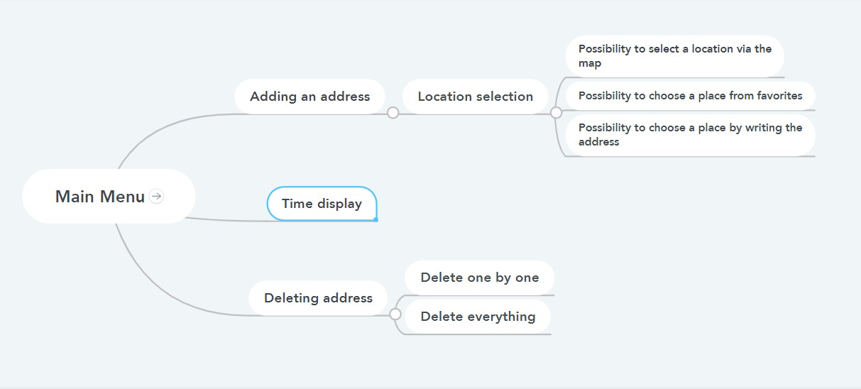

**4.1.4 requirements for information support**

The size of our application component will take about 50-55 MB.

**4.1.5 Software requirements**

Software size from 60 to 70 MB.

**4.1.6 Requirements for the construction of the algorithm**

The algorithm must deal with Data — input, intermediate, output. In order to clarify the concept of data, the final alphabet of the source symbols (numbers, letters, etc.) is fixed and the rules for constructing algorithmic objects are specified.

**4.1.6.1 Requirements for user requests for data from the database**

* Scheme of routes of vehicles
* Vehicle stop pattern
* User Reviews
* Favorite routes history

**4.1.6.2 Requirements for source code/programming languages**

Almost all source code will be written in Android Studio . The design will be made in Figma . And in Intellij Idea will be like an integrated development environment.

**4.1.7 OS requirements**

Android

**4.1.8. Building an algorithm**

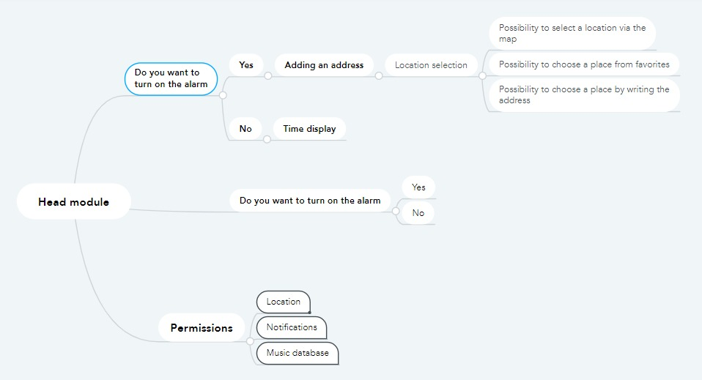

**4.2. Reliability requirements:**

Accurate location tracking from the user's phone, accurate indication of stops within the selected city. Actual display of traffic jams in the city (traffic).

**4.2 Reliability requirements:**

Minimize the origin of failures in location tracking, as well as incorrect display of stops.

**4.3. IS Security**

**4.3.1. Copyright protection**

The copyright will be in the form of a copyright in the application itself, but it will not be shown in large font.

Example: **© Dias and Adil**

Author 1: Alimzhanov Adil Askhatovich

Email: 29424@iitu.edu.kz

Author 2: Zhumabekov Diaz Zhumabekuly

Email: 29434@iitu.edz.kz

**4.3.2. Data protection**

**4.3.2.1. Protection methods**

With the help of cryptographic methods , information encryption and protection against accidental or intentional change of information will be used .

**4.3.2.2. Protection algorithm**

We looked through most of the encryption algorithms and settled on the choice of E CC ( elliptic curve cryptography ). This is a new generation asymmetric encryption algorithm. Judging by the article, ECC is in great demand today and is becoming more popular among IT giants .

**4.3.2.3. Antivirus protection**

Today, Kaspersky is in great demand and we also want to choose it.

**4.3.2.4. Attack protection**

The above says that elliptic cryptographic encryption will be used. curve cryptography , ECC for short . In case of virus attacks, Kaspersky Anti-Virus will be used.

**4.3.2.5. Burglary protection**

The above says that elliptic cryptographic encryption will be used. curve cryptography , ECC for short .

**4.4 Operating requirements**

**4.4.1 Operating conditions**

**4.4.1.1 Climatic operating conditions**

The operation of the application will not depend on climatic conditions, only after a couple of clicks will traffic be shown if traffic depends on climatic conditions.

**4.4.1.2 Qualification and number of employees**

2 Developers who work on the application itself, it is also possible that 1 designer, 1 cybersecurity will be involved .

**4.4.2 Development of a reference guide**

The reference manual will be in the format write to the author.

**4.5 Technical requirements :**

**4.5.1 The recommended range of monitor resolutions at which the software will be viewed is**

There will be no recommended range of monitor resolutions, as this application is for all kinds of smartphones and tablets. The application will not be adapted for PCs and laptops.

**4.5.2 Minimum monitor resolution range at which the software will be viewed**

The minimum resolution range of the monitor will be like that of the smallest smartphones, this is 640 × 960

**4.5. 3 Recommended PC configuration**

The application will not be adapted for PCs and laptops.

**4.5. 4 Minimum PC configuration**

The application will not be adapted for PCs and laptops.

**4.6. Non-technical requirements for IP :**

**4.6.1 Adaptability**

The application will be adapted for tablets and all types of smartphones. The application will not be adapted for PCs and laptops.

**4.6.2 Intellectual development**

Suggestion to choose the location of the alarm clock by frequently used.

**4.6.3 Consistency**

The software will be fully functional at the system level.

**4.6.4 Full functionality**

The full functionality of the application is shown in the precise operation of the location, at the same time as the alarm goes off.

**4.6.5 Integrity**

Absolute integrity of the design in conjunction with all the necessary plugins.

**4.6.6 Quality**

The quality of the software is high. The absence of any freezes, problems in use, etc.

**4.6.6.1 Functionality**

Users must be completely satisfied with the ability to add their favorite routes, accurate tracking of their location in real time. As well as using the optimal route, based on the amount of traffic in the city.

**4.6.6.2 Reliability**

Problems with use can only arise due to the presence of a bad Internet connection. As long as you have a stable Internet connection, there shouldn't be any problems. Stable operation will be provided even on older models of smartphones.

**4.6.6.3 Ease of use**

The most simple design and functionality of the application. Open the map, choose the best route, select the desired stop and set the alarm.

**4.6.6.4 Efficiency**

The presence of a location system, a city map, and an alarm clock. These things will not affect the effectiveness of our software in any way.

**4.6.6.5 Maintainability**

There will be systems that can fix the location problem.

**4.6.6.6 Learning opportunity**

As such, no training is required to use it. But of course there will be hints.

**4.6.6.7 Modifiability**

On the map there will be stops not only within the city, but also outside it. That is, the routes of intercity public transport.

**4.6.6.8 Mobility**

The ability to continue to function when moving from one environment to another, including organizational, hardware and software aspects of the environment, the ability of software and a computer system as a whole to continue to function when it is physically moved in space.

Software portability is the ability of software to run on different hardware platforms or under different operating systems.

The application will be created for Android . There will be no problems with the mobility of the application on different models of Android smartphones .

**4.6.6.9 Limb**

Reverse failure rate.

Negative.

**4.6.10 Accuracy**

Depending on network speed.

**4.6.6.11 Autonomy**

A property that characterizes the ability of a PC to perform its intended functions without the help or support of other software components.

software.

Nothing will be available offline.

**4.6.6.12 Stability**

The ability to maintain a given level of performance in case of failures and violations of interaction with the external environment.

Quite high.

**4.6.6.13 Security**

Ability to prevent unauthorized, i.e. without the participation of the person who is trying to implement it, and prevent access to data and applications.

No registration, so no data security issues.

**4.6.6.14 P - documentation**

The property is characterized by the presence, completeness, clarity, accessibility and visibility of educational, methodological and reference documentation necessary for the use of the PC.

**4.6.6.15 Content**

The property is characterized by the presence in the composition of the information necessary and sufficient to understand the purpose of the SS, the assumptions made, the existing restrictions, the input data and the results of the operation of individual components, as well as the current state of the program in the process of their work.

Information about the state of traffic, and the remaining number of stops before the appointed one.

**4.6.6.16 Sociability**

A property that characterizes the degree to which the SS

facilitates task description or data entry, and provides useful information in a form and content that is easy to understand.

The most understandable.

**4.6.6.17 Time efficiency**

The ability of the software to produce the expected results and also to transfer the required amount of data in the allotted time.

The shortest possible.

**4.6.6.18 Memory efficiency**

A measure that characterizes the ability of a PC to perform its functions under certain restrictions on the use of memory.

Quite high.

**4.6.6.19 Effective devices**

The measure is the economical use of machine devices for the task at hand.

Fairly economical use .

**4.6.6.20 C - documentation**

Properties characterizing, from the point of view of the availability of documentation, the requirements for software and the results of various stages of software development, including opportunities, limitations and other features of the software, as well as their justification.

**4.6.6.21 Legibility**

An indicator of the effort expended by the user in accepting the set of concepts on which the software is based and their applicability to solving their problems.

Everything in the application is as clear and legible as possible.

**4.6.6.22 Structured**

A property that characterizes the PS program in terms of organizing related parts into a single whole in a certain way (for example, in accordance with the principles of structured programming).

**4.6.6.23 Readability**

Software readability - characteristics of a software product that:

- Minimize user effort in preparing input data, application software and evaluating results

- May cause positive emotions in a particular user or are implied.

A property that characterizes the ease of perception of the text by programs ( indentation , fragmentation, formatting ).

**4.6.6.24 Extensibility**

A property that characterizes the software's ability to use more memory to store data or expand the functionality of individual components.

**4.6.6.25 Modularity**

A property that characterizes the organization of software in terms of its programs of discrete components, such that a change in one of them has minimal impact on the other components.

**4.6.6.26 Device independent**

A property that characterizes the ability to work on various equipment (different types, brands and models of computers).

**5 PSYCHOLOGICAL FEATURES**

**5.1.1 Aesthetic appearance**

The middle few buttons are in the center of the main menu.

**5.1.2 Selecting a style**

Rich appearance. Everyone wants to feel rich, and we want to convey this feeling even in an alarm clock.

**5.1.3 Color solution**

Black color and gray color.

**5.2 Location of interface elements**

Graphically, the display will look like a regular alarm clock but with a stylish design and interface.

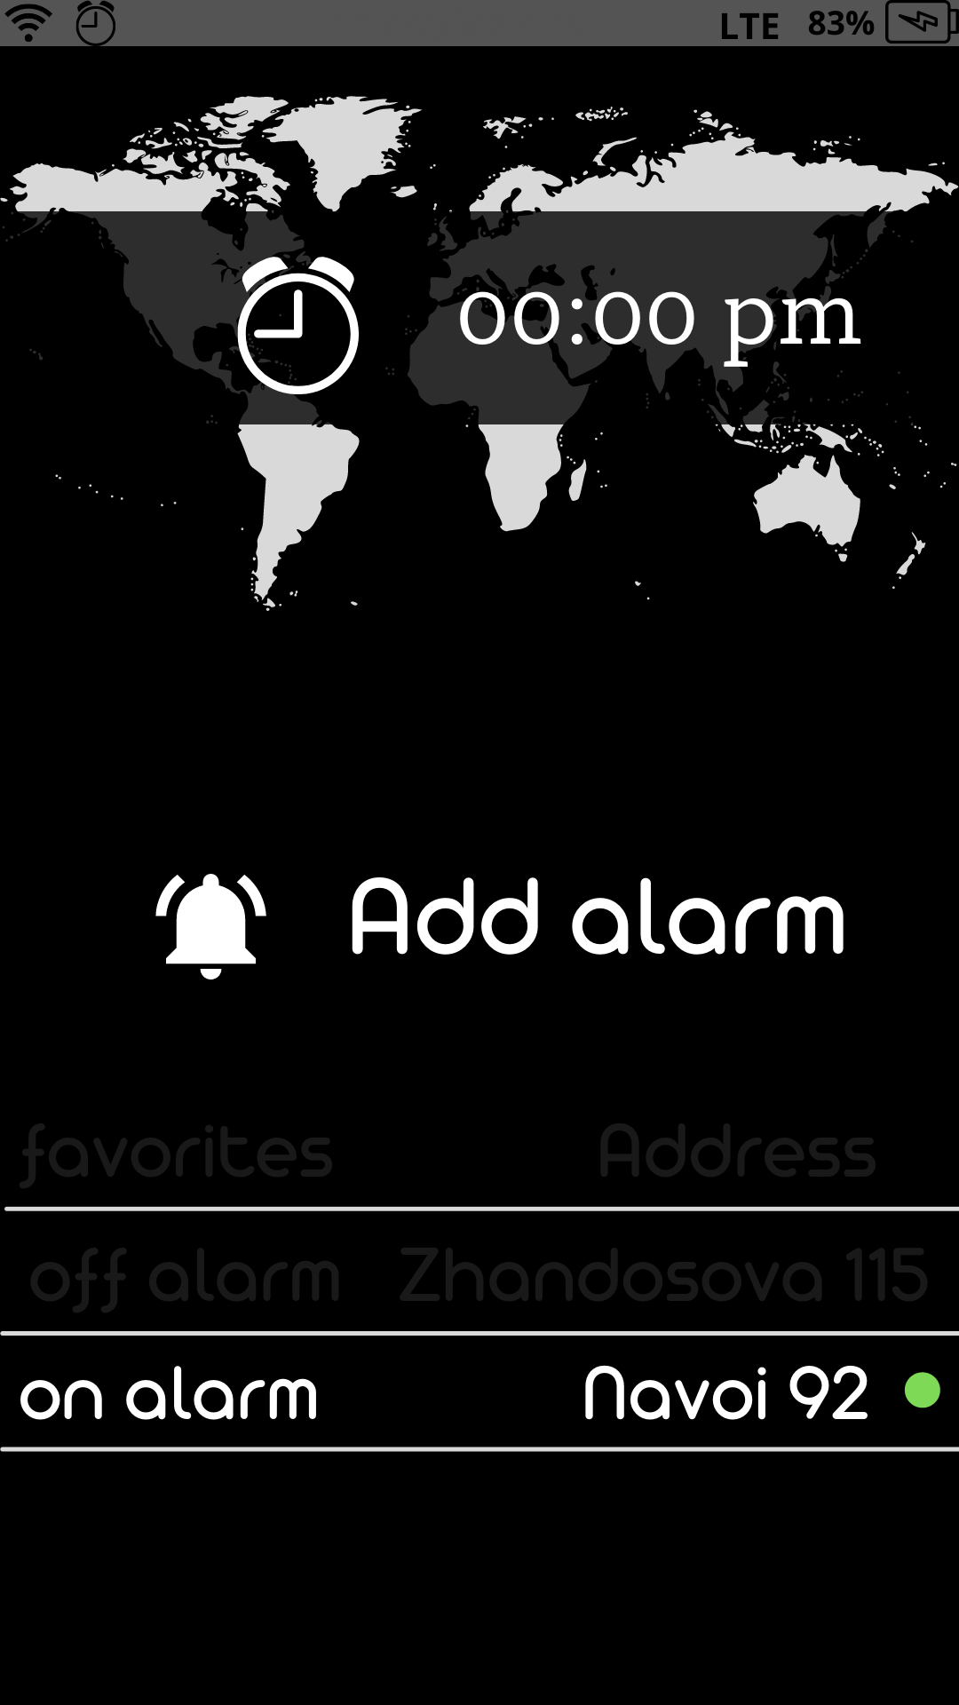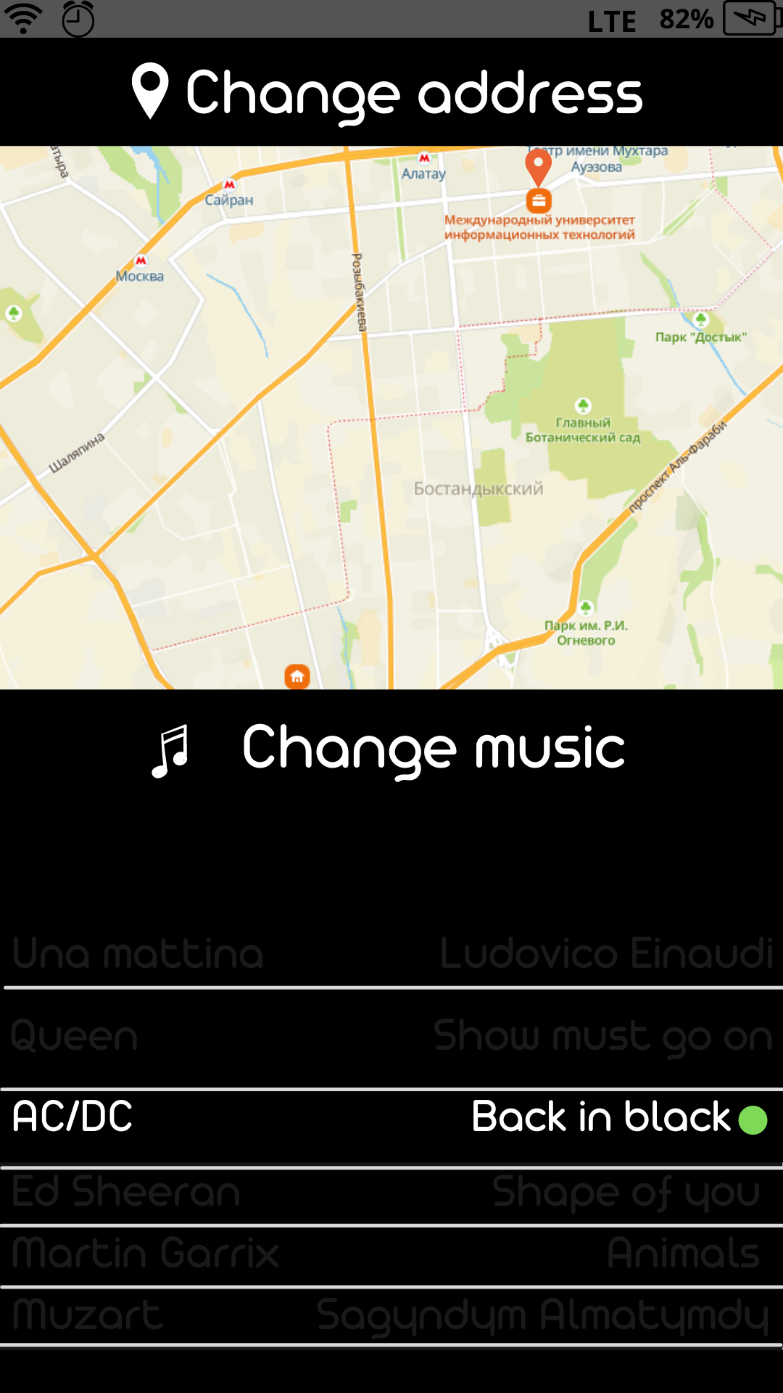

Figure - Main menu interface

**5.3 Ergonomics**

Friendliness, convenience, everything you need is on the main menu in the usual places.

**5.4 Target audience**

**5.4.1 Age of users**

The age of the target audience is not available, but we assume that it is from 16 to 40

**5.4.2 Their mood, temperament, etc.**

Does not matter.

## **CREATING UML ER CHARTS (DEFINITION)**



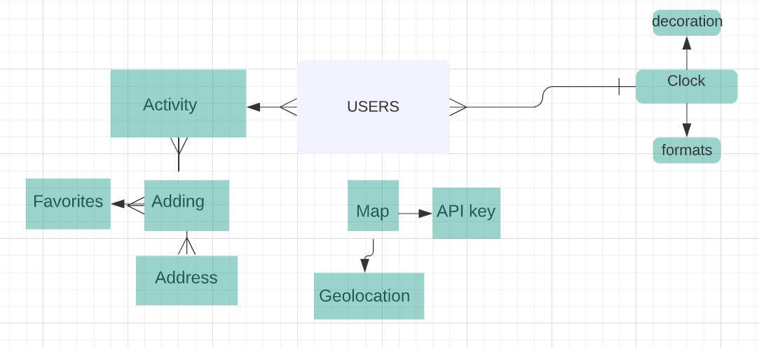

## **CREATING DB TABLES.**

* + 1. Creating a physical database in MS Access

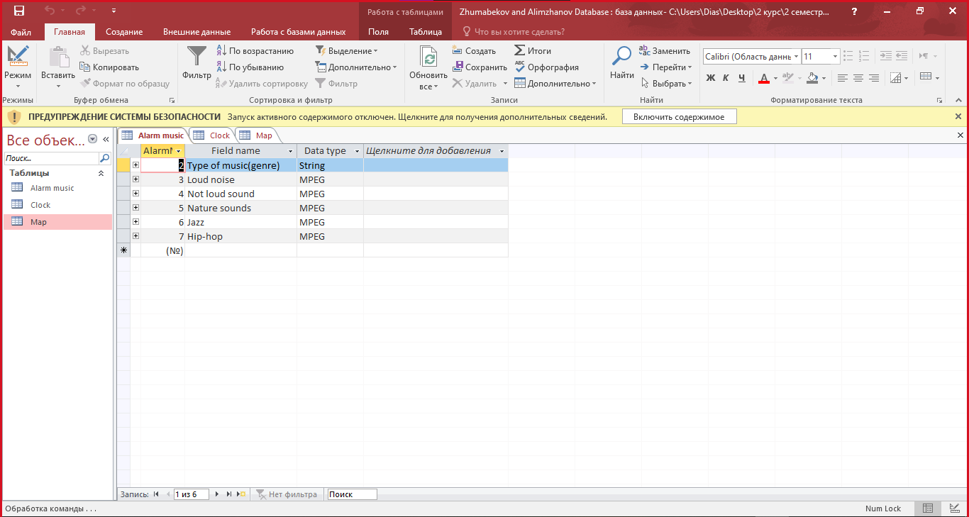

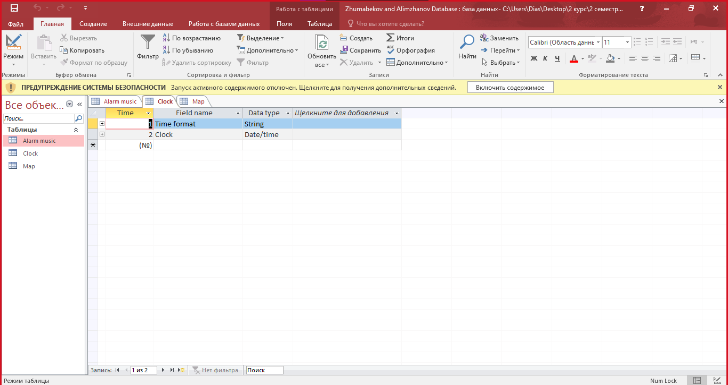

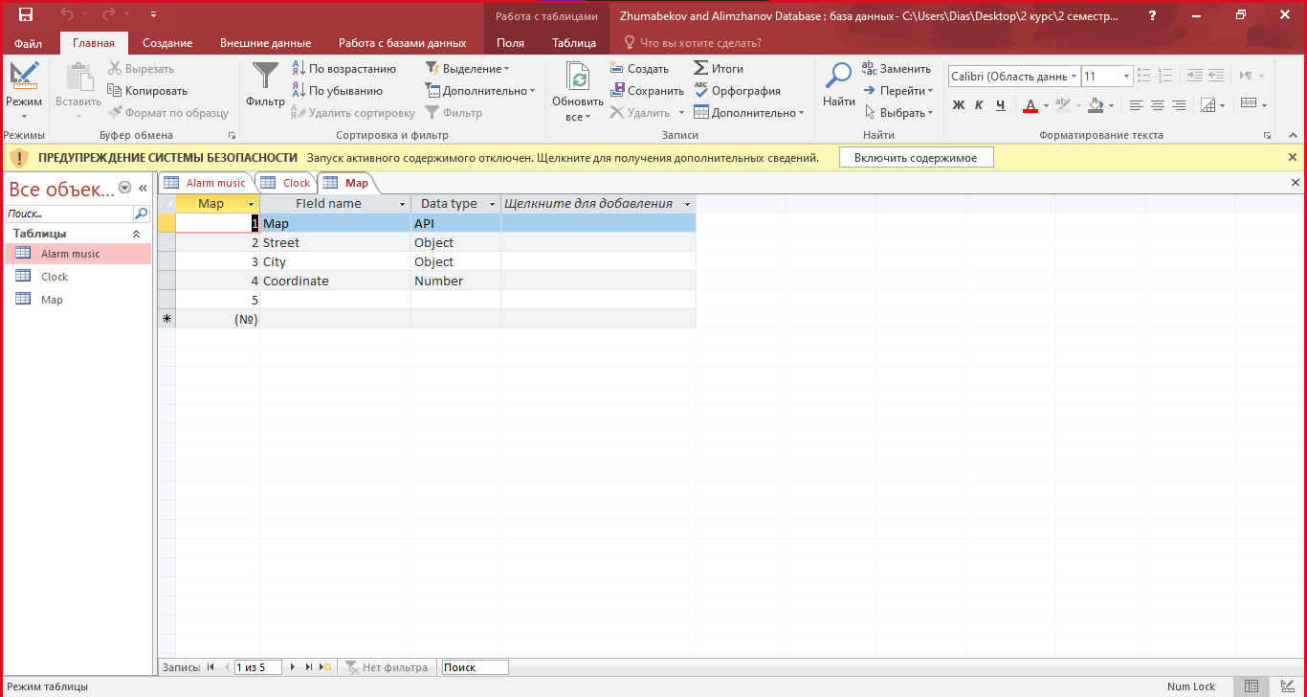

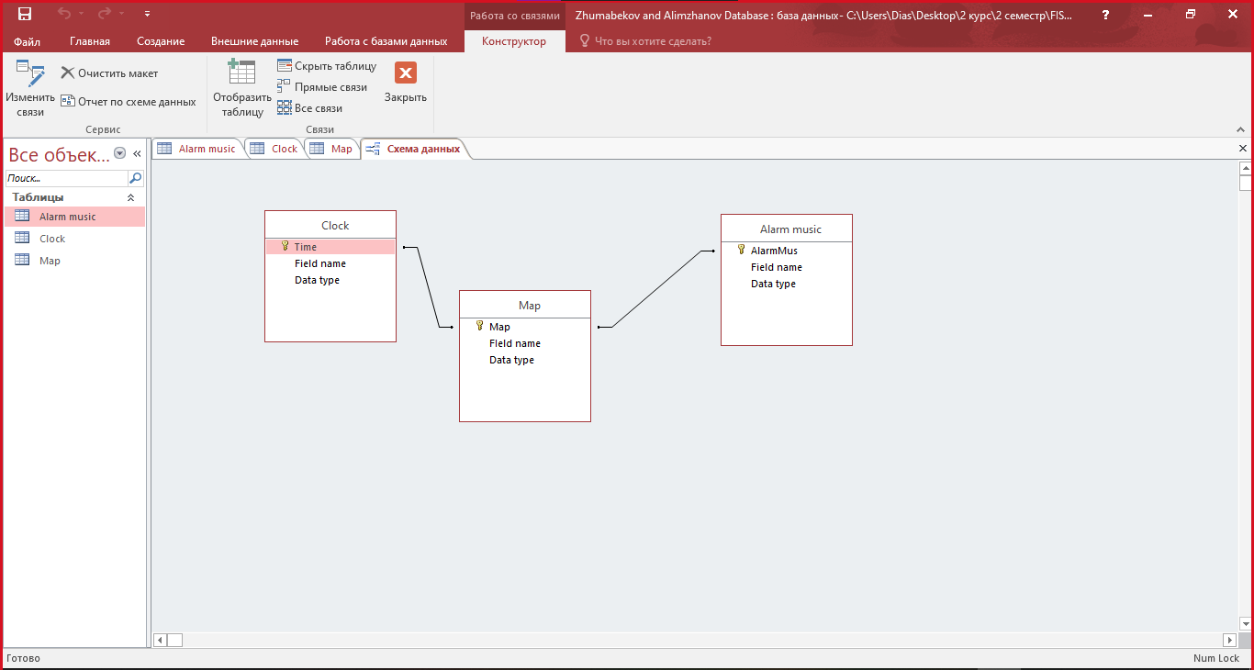

1. **Software cost estimation**
   1. **Calculate hours**

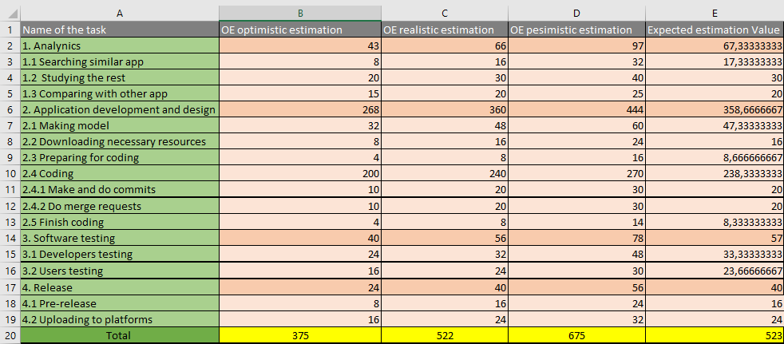

**7.2 Additional project cost**

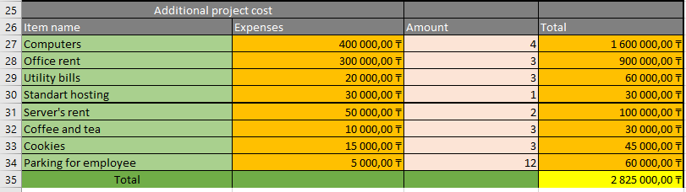

**7.3 Total project cost (+ additional project cost, risks)**

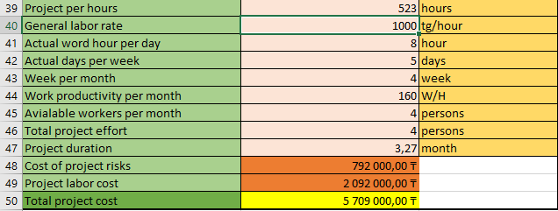

**7.4 Project risks**

